SE LAB 1
Name: Bhooshan Deshpande

SRN: PES1UG24AM351

SEC: AIML F
REQUIREMENTS TABLE:
Req ID | Type | Description | Priority | Acceptance Criteria | Rationale (short) | Comments
FR-001 | Functional | The system shall allow authenticated students to search real-time availability and reserve a maximum 2-hour slot for hardware up to 7 days in advance. | High | Pass: Slot locks and token generates.  Fail: Allows double-booking or exceeds 2 hours. | Prevents equipment scheduling conflicts
FR-002 | Functional | The system shall automatically verify equipment calibration status before confirming any slot reservation. | High | Pass: Reservation proceeds only if calibration flag is 'Valid'.  Fail: Allows booking uncalibrated hardware. | Ensures safe and accurate experiment results
FR-003 | Functional | The system shall enable Lab Technicians to update equipment calibration records and flag hardware as 'Under Maintenance'. | Medium | Pass: Updating status immediately blocks booking for that unit.  Fail: Hardware remains bookable during maintenance. | Keeps inventory and equipment health up to date
FR-004 | Functional | The system shall log check-in/check-out timestamps and calculate disciplinary late-return penalties automatically. | High | Pass: System applies fine/flag if check-out time > reservation end time.  Fail: No penalty recorded for late returns. | Enforces discipline and timely equipment availability
FR-005 | Functional | The system shall send automated notification reminders to students 15 minutes before their reserved slot begins. | Low | Pass: Notification dispatched 15 mins prior to start time.  Fail: Notification missing or sent after start time. | Reduces missed reservations and idle hardware
NFR-001 | Nonfunc. | The system shall process concurrent slot reservation requests within 200 ms with strict database-level lock isolation. | High | Pass: Benchmarking confirms target latency under peak load without race conditions.  Fail: Response time > 200 ms or race condition occurs. | Prevents duplicate bookings under heavy load
NFR-002 | Nonfunc. | The system shall enforce role-based access control (RBAC) ensuring only authorized technicians can override reservation locks. | High | Pass: Student credentials denied when attempting technician overrides.  Fail: Unauthorized user gains override access. | Maintains administrative integrity and security

ACTORS:
Student: Reserves slots, checks in/out hardware, views notifications.
Lab Technician: Manages calibration, updates equipment status, overrides locks.
System Clock / Scheduler (Secondary): Triggers late penalties and automated reminders.

USE CASES:
- UC-01: Reserve Equipment Slot
- UC-02: Verify Calibration Status (include in UC-01)
- UC-03: Manage Equipment & Calibration (Lab Technician)
- UC-04: Check-In / Check-Out Hardware
- UC-05: Apply Late Fine (extend to UC-04 when return is overdue)

UML DIAGRAM
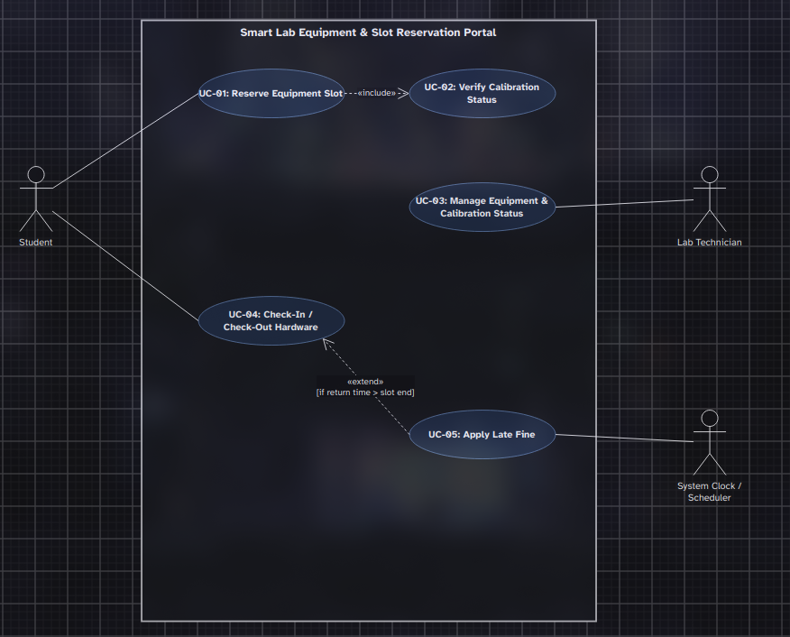

USE CASE FLOW SPECIFICATION:
Use Case ID: UC-01 Use Case Name: Reserve Equipment Slot Primary Actor: Student Preconditions: Student is logged in; requested hardware exists in inventory. Postconditions: Slot is locked, database updated, and reservation token generated. Main Success Scenario:
- Student selects desired equipment (e.g., Oscilloscope) and views real-time availability.
- Student selects an available slot (maximum 2 hours) within 7 days.
- System triggers UC-02: Verify Calibration Status.
- System confirms equipment is calibrated and available.
- System locks the time slot and issues a unique reservation token to the student.
Alternate Flow (A1: Equipment Uncalibrated):
3a. System detects equipment calibration status is 'Expired' or 'Pending'.
3b. System blocks reservation and displays message: "Selected hardware is currently uncalibrated and unavailable."
3c. System prompts student to select an alternate calibrated unit or time slot.

